***Directions:*** Turn to Page 83-84 and complete Questions 16 - 20 (10 points each). Display a snippet of the code and the output below:

**COP2335: Object-Oriented Programming Lab 1**

16) Write a program that displays the following pattern (diamond):

*

***

*****

*******

*****

***

*

**Snippet of the Code:**

**Snippet of the Output:**

17) Kathryn bought 750 shares of stock at a price of $35.00 per share. She must pay her stockbroker a 2 percent commission for the transaction. Write a program that calculates and displays the following:

The amount paid for the stock alone (without the commission).

The amount of commission.

The total amount paid (for the stock plus the commission).

**Snippet of the Code:**

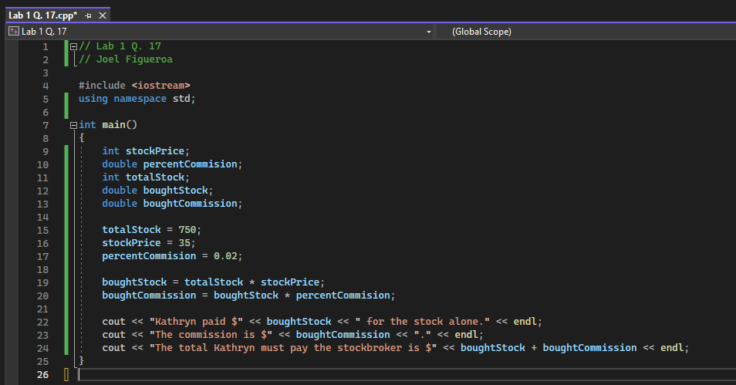

**Snippet of the Output:**

18) A soft drink company recently surveyed 16,500 of its customers and found that approximately 15 percent of those surveyed purchase one or more energy drinks per week. Of those customers who purchase energy drinks, approximately 58 percent of them prefer citrus-flavored energy drinks. Write a program that displays the following:

The approximate number of customers in the survey who purchase one or more energy drinks per week.

The approximate number of customers in the survey who prefer citrus-flavored energy drinks.

**Snippet of the Code:**

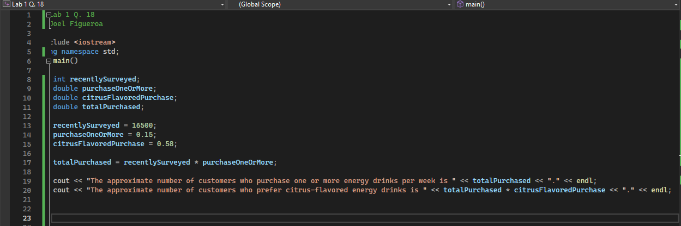

**Snippet of the Output:**

19) The average July high temperature is 85 degrees Fahrenheit in New York City, 88 degrees Fahrenheit in Denver, and 106 degrees Fahrenheit in Phoenix. Write a program that calculates and reports what the new average July high temperature would be for each of these cities if temperatures rise by 2 percent.

**Snippet of the Code:**

**Snippet of the Output:**

20) A particular brand of paint covers 340 square feet per gallon. Write a program to determine and report approximately how many gallons of paint will be needed to paint two coats on a wooden fence that is 6 feet high and 100 feet long.

**Snippet of the Code:**

**Snippet of the Output:**

